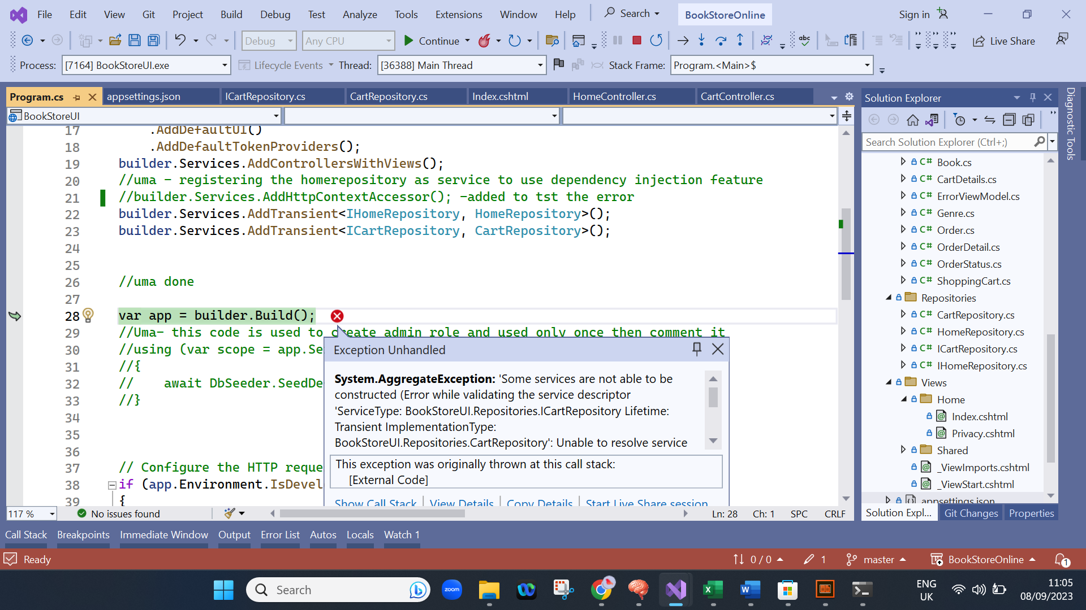

Error : system.Aggregateexception

Solution:In cartRepository, private readonly HttpContextAccessor _httpContextAccessor; was used, but it should use the interface instead of service class like this,

private readonly IHttpContextAccessor _httpContextAccessor